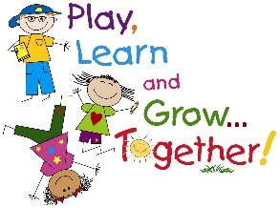
Class Supplies for Kindergarten 2017-2018

- $25.00 Student fee to cover duo-tangs, construction paper, journals, communication folders, craft supplies, photo finishing, special materials for art projects, exploratory, etc.
- Fees for on-sight special events (i.e. guest speakers, musical guest/groups, professional artists, drama groups, etc.) will be collected on as needed basis.

PLEASE DO NOT LABEL THE FOLLOWING ITEMS:
- 12 black triangle pencils (2 packs of 6) (NOT made in China)
- 2 white erasers
- 1 box of Crayola crayons
- 1 package of pencil crayons (Crayola or Laurentian)
- 2 packages of fat Crayola markers
- 6 large glue sticks
- 1 box of Ziploc bags, small or medium size
- 1 box of Ziploc bags, size large
- 2 boxes of Kleenex/tissue
- 1 package of whiteboard markers (Dollar store brand)
- 1 whiteboard (approximately 8” X 10” size, Dollar store brand)
- 1 large coil scrapbook (Hilroy brand, please)
- 1 package of colored cardstock paper (not construction paper)

PLEASE LABEL THE FOLLOWING ITEMS:
  - Lunch bag and backpack
  - Indoor white-sole sneakers (if your child cannot tie, please send slip-on or Velcro sneakers).
  - Change of clothes (put in a plastic bag and label the bag).

Some of these supplies may need to be replenished during the school year.

